To ensure smooth processing, please name your file as follows:
(Your Name) March_Full_Stack26(Module)assignments, and send it to fullstack_ecap_assignments@excelr.com
Front End Assignments

1.HTML
1. Write a program to design semantic and non - semantic tags with web page form layout to get this desired output ?

Expected output:

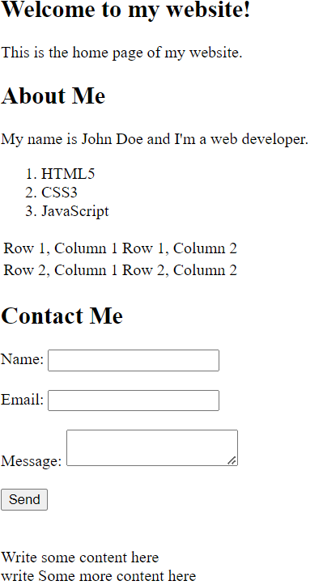

2.Write a program to display the menucard using table and using inline css properties for color?

Expected output:

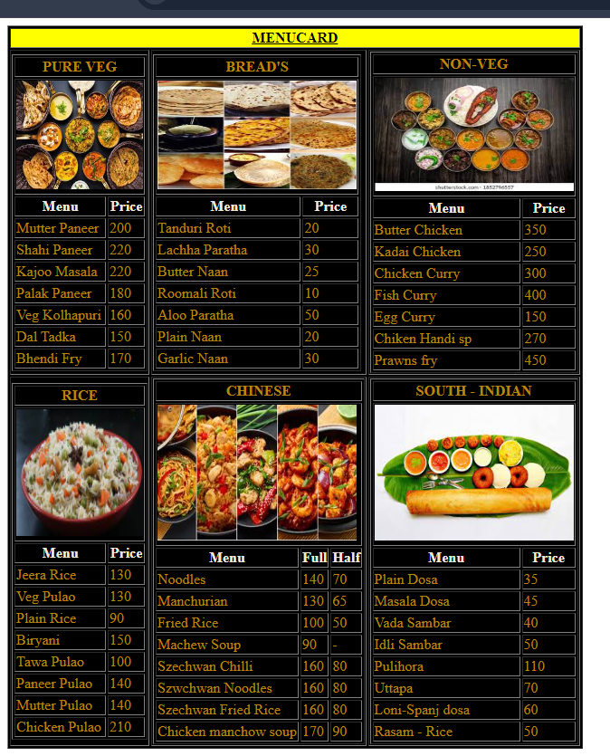

3.Write a program to show all form input controls in HTML5 as given below ?

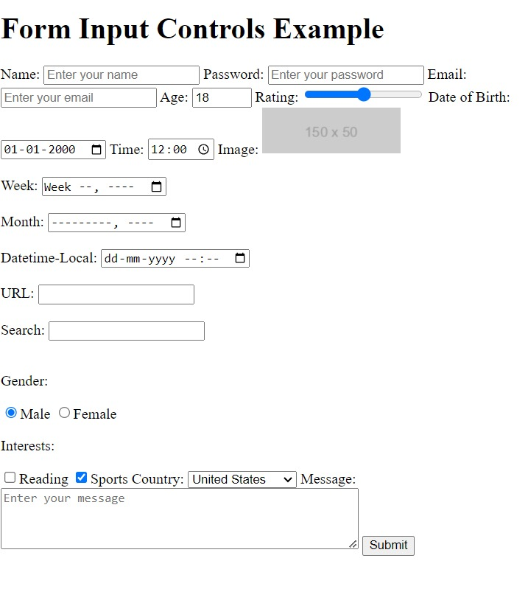
Expected output:

2.CSS

4.design flipkart login page?
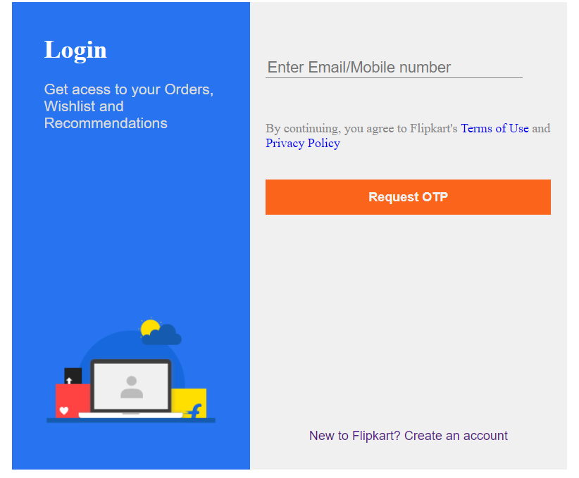
5.Write a program and display all flexbox properties?
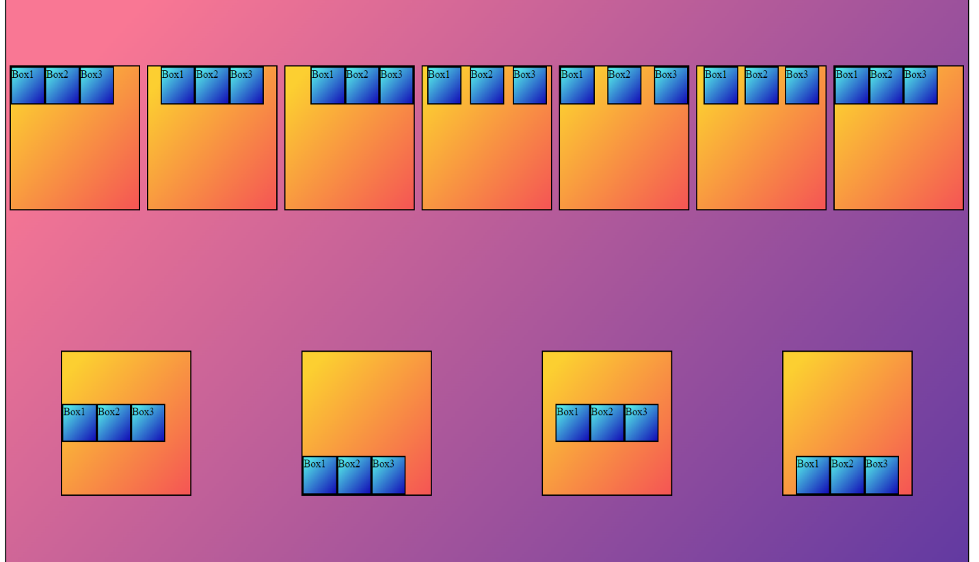
6.Write a program to design standard web layout using GRID?

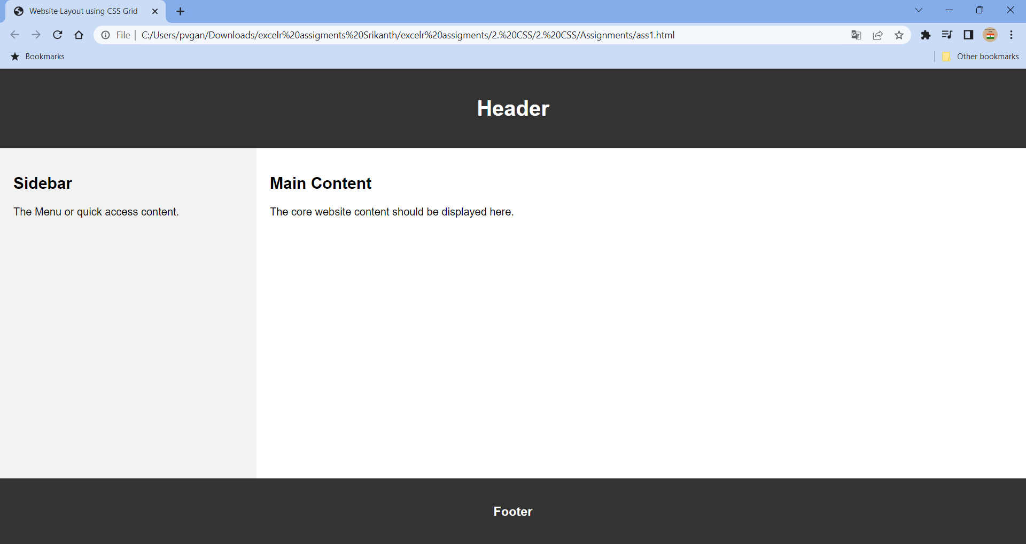

3.Java Script

7.Write a program to demonstrate JavaScript loops, operators and conditions?
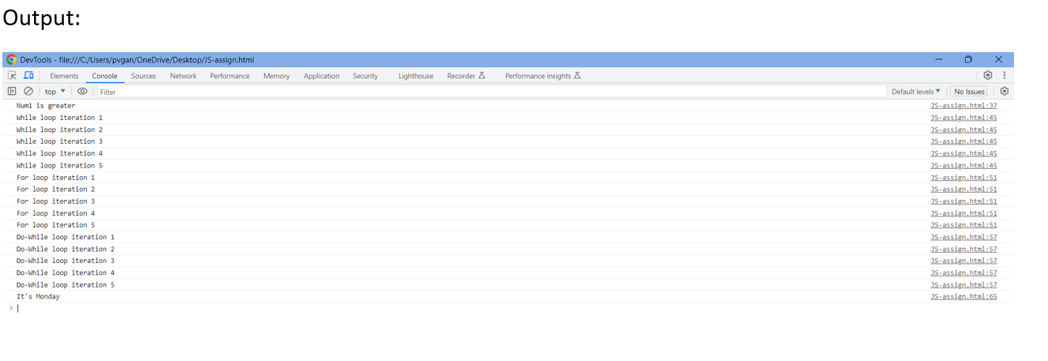

8. Write a program to create bulb design using dom model and provide functionality using function?
1)condition one : if click on button ask to color and display on bulb
2)condition two:if click off button display the bulb color white
Output

